

Blackheath Primary School
Attendance Policy

Date of issue: September 2026

Review date: September 2027

The name and contact details of the Senior Attendance Champion – the senior leader responsible for the strategic approach to attendance in our school, is:

Name: Mr Hytch
Contact details: attendance@bps.sandwell.sch.uk

The name and contact details of the school staff member pupils and parents should contact about attendance on a day-to-day basis is:

Name: Mrs Moyles
Contact details: attendance@bps.sandwell.sch.uk
0121 559 1033 (Option 2)

The name and contact details of the school staff member pupils and parents should contact for more individual support with attendance

Name: Mr Hytch
Contact details: attendance@bps.sandwell.sch.uk

Staff consulted: October 2026

Ratified by the Governing Body: October 2026

Review Date: September 2027

Index

- Introduction:
- Expectation & why regular attendance is so important
- Legal framework & School Guidance
- Regular Attendance
- Pupil contact information
- Promoting & rewarding good attendance
- Understanding Types of Absence
- Absence procedures
- Persistent absence (PA)
- Escalation: fixed penalty notices and legal actions for attendance concerns
- Absence data
- Authorised Absence
- Application for Leave of Absence during term time
- National Framework for Penalty Notices
- Religious observances
- Inclement weather/school closure
- Appointments
- Pupils with Additional Health Needs (SEN, physical, Social emotional and mental health)
- Part Time Timetables
- Lateness
- How we manage lateness
- Staged approach to supporting barriers to punctuality
- Sandwell Attendance support services (SASS)
- Children not collected after school hours
- Key roles and responsibilities
- Children Missing Education (CME)
- Appendix

1. Introduction

For our children to gain the greatest benefit from their education, it is essential that they attend school regularly. Good attendance is a learned behaviour and is central to the school vision, values and ethos.

From the 25th September 2017 onwards, the Governing body agreed to adopt Sandwell Attendance Support Service (SASS) guidance, systems and processes in order to implement the key elements of improving attendance as outlined in the DFE’s Working Together To Improve Attendance 2024:

- Expect – Aspire to high standards of attendance from all pupils & parents and build a culture where we all can, and want to, be in school and ready to learn by prioritising attendance improvement across the school
- Monitor – Rigorously use attendance data to identify patterns of poor attendance (at individual and cohort level) as soon as possible so all parties can work together to resolve them before they become entrenched
- Listen & Understand – When a pattern is spotted, discuss with pupils and parents and listen to and understand barriers to attendance and agree how all partners can work together to resolve them
- Facilitate Support – Remove barriers in school and help pupils and parents to access the support they need to overcome barriers outside of school. This might include an early help or whole family plan where absence is a symptom of wider issues
- Formalise Support – Where absence persists and voluntary support is not working or not being engaged with, partners should work together to explain the consequences clearly and ensure support is also in place to enable the families to respond.
- Enforce – Where all other avenues have been exhausted and support is not working or not being engaged with, enforce attendance through statutory intervention: a penalty notice in line with the National Framework or prosecution to protect the pupil’s right to an education

The school therefore regularly reviews this policy and practice, as it is seeks to offer support to families with barriers to healthy attendance. The school will always communicate its expectations and support measures, to maximise attendance.

The school has also revised this policy in response to National and local concerns around attitudes to Attendance following Covid 19 disruption and associated attendance guidance.

The remainder of this policy sets out the finer details on how we aim to work together along with measures that are in place to support, challenge in order to maximise attendance.

Should you require further information or support around attendance, the school has a designated Attendance Champion: Mr Hytch attendance@bps.sandwell.sch.uk or 0121 559 1033 (Option 2) alongside other team members who can support.
2.Expectation & why regular attendance is so important:

Our school strategy is ‘Challenge 97+%’ and we strive to achieve this and higher. To achieve this we use On Time In School (OTIS) to form our rewards and expectations, supporting pupils legal right to education.

A Blackheath child should be at school and on time:

- 8:45 Reception – Year 6,
- Morning Nursery 8:30am
- Afternoon Nursery 12:30pm

This should be every day the school is open, unless the reason for the absence is totally unavoidable. This is the best way to support a child’s learning moreover their legal right to education. Only by doing this, can a child meet the schools high expectations of being On Time In School (OTIS) and Challenge 97+%, which in turn will ensure stronger attainment, wellbeing & wider development.

Where attendance is not possible, adults must inform school of the reason why by 9:15am at the latest, to ensure their child is safeguarded and the reason for absence is coded accurately:
- Email attendance@bps.sandwell.sch.uk
- Tel 0121 559 1033 (Option 2)

Any absence affects the pattern of a child’s schooling. Regular absences will seriously affect their learning (See appendix 3, Graph of impact). Any pupil’s absence disrupts teaching routines and may also affect the learning of others in the same class too. Ensuring your child’s regular attendance at school is your legal responsibility, and permitting absence from school without a good reason creates an offence in law and may result in prosecution or penalty notices. School however is always here to offer support.

3.Legal framework & School Guidance
This policy has due regard to the following legislation and guidance, including, but not limited to:
- The Education Act 1996
- The Equality Act 2010
- The Education (Pupil Registration) (England) Regulations 2006 DfE School Attendance Advice 2019
- DfE (2013) ‘Ensuring a good education for children who cannot attend school because of health needs’
- DfE (2015) ‘Supporting pupils at school with medical conditions’2022, updated Sept 5th 2023
- DfE Keeping children Safe in education
- Working together to improve school attendance (Pre and post Aug 19th 2024 editions)

The Department for Education (DfE) has produced statutory guidance for maintained schools, academies, independent schools, and local authorities. It is called “Working together to improve school attendance” and it includes a National Framework in relation to absence and the use of legal sanctions. Our School Attendance Policy reflects the requirements and principles of that guidance.

This policy is written with the above guidance in mind and underpins our school ethos to:
- promote children’s welfare and safeguarding;
- ensure every pupil has access to the full-time education to which they are entitled;
- ensure that pupils succeed whilst at school;
- ensure that pupils have access to the widest possible range of opportunities at school, and when they leave school.

It has been developed in consultation with school governors, teachers, local Headteacher Associations, the Local Authority and parents and carers. It seeks to ensure that all parties involved in the practicalities of school attendance are aware and informed of attendance matters in school and to outline the school’s commitment to attendance matters. It details the responsibilities of individuals and groups involved and the procedures in place to promote and monitor pupil attendance.

In addition, all schools follow the DfE’s statutory safeguarding guidance, Keeping Children Safe in Education, which emphasises the importance of understanding the potential vulnerabilities of children who are missing or absent from education.
https://www.gov.uk/government/publications/keeping-children-safe-in-education--2

Please see also refer to other sections in the policy:
- Escalation: fixed penalty notices and legal actions for attendance concerns
- National Framework for Penalty Notices section later in the policy

Regular Attendance:

Helping to create a pattern of regular attendance is everybody’s responsibility - parents, pupils and all members of school staff.

Our policy aims to raise and maintain levels of attendance by:
- Promoting a positive and welcoming atmosphere in which pupils feel safe, secure and valued.
- Raising and maintaining a whole school awareness of the importance of good attendance and punctuality.
- Ensuring that attendance is monitored effectively and reasons for absences are recorded promptly and consistently.

5. Pupil contact information:

To enable school and the local authority to offer support for attendance and ensure safeguarding practices, the person responsible for a child’s attendance must:
- Provide accurate and up-to-date home contact details, updating the school if the details change.
- Download and enable notifications on the Arbor Parent portal App

6.Promoting & rewarding good attendance

At Blackheath Primary school, we believe in developing good patterns of attendance and set high expectations for the attendance and punctuality for all our pupils from the outset. It is a central part of our school’s vision, values, ethos and day to day life. We recognise the strong connections between attendance, attainment, safeguarding and wellbeing.

Helping to create a pattern of regular attendance is the responsibility of parents, pupils and all members of school staff.

To promote good attendance the school:
- Submit a daily attendance return to the Department of Education, in line with the legal expectations placed on all schools.
- Build strong relationships and work jointly with families.
- Accurately complete admission attendance registers and have effective day to day processes in place to follow-up absence as required by law;
- Report to parents/carers regularly on their child’s attendance and the impact on their progress.
- Consistently and regularly promote and communicate the benefits of good attendance on education and future aspirations
- Raise awareness about the importance of punctuality for education and wellbeing
- Send out regular expectation reminders about OTIS and Challenge 97+%
- Monitor attendance on a weekly basis, communicate and share with parents and staff any concerns/achievements (half termly)
- Give parents/carers details on whole school attendance in newsletters
- Offer support to parents e.g. Free taxi, home collection or morning wakeup
- Run late gates to offer face to face support and help
- Inform parents/carers, at least termly, about their child’s attendance percentage, where it is a concern and inform them of potential support available
- Run promotional events when parents, pupils and staff can work together on raising attendance levels across the school e.g. Parents Evening, Breakfast clubs.
- Where there are delays in accessing external school support and services, temporary solutions will be explored to help attendance in the interim
- Designate special events in response to attendance data e.g. special lunch or day

Celebrate & Reward:
- Award Yearly 100% attendance certificate and reward e.g. badge/sticker. Pupils receive termly 100% attendance and reward e.g. badge/sticker
- Celebrate Pupils who meet our target of 97%+ in a term. Pupils will receive an attendance certificate and reward e.g. badge/sticker+
- Reward good or improving attendance through class competitions, certificates, events and attendance improvement postcards/letters.
- Classes with 97%+ weekly attendance and are celebrated in weekly assembly, awarded with attendance cup and bonus house point and extra playtime.
- Celebrate good attendance by displaying individual and class achievements weekly
- Positive postcards are sent home to those with improving attendance
- Personalised support/improvement/awareness letters

7.Understanding Types of Absence

Every half-day absence from school has to be classified by the school (not by the parent), as either authorised or unauthorised. This is why information about the cause of any absence is always required. Each half-day is known as a ‘session’.

Authorised absences are morning or afternoon sessions away from school for a genuine reason such as illness, medical or dental appointments which unavoidably fall in school time, emergencies or other unavoidable cause.

Unauthorised absences are those which the school does not consider reasonable and for which no ‘leave’ has been granted. This type of absence can lead to the school referring to the Local Authority for penalty notices and/or legal proceedings. This also applies to illnesses where the school does not feel satisfied with the medical evidence provided. An unauthorised absence is also used for children who are late to school after registers close (See Lateness below)

Following DFE guidance for attendance, the school continues to adopt attendance codes appropriate to covid related issues and will continue to throughout the year in response to any National situation. Absence is therefore monitored daily.

8.Absence procedures
If your child is absent Parents/carers/guardians must contact the school before 9.15am on the first day of any absence and each day of absence to follow, either by:

- Telephone 0121 559 1033 (Option 2),
- Email: attendance@bps.sandwell.sch.uk’ FOA Miss Moyles (Attendance officer) Mr.Hytch (Attendance Champion)
- In person at the school office on the first day of absence by 9:15a.m.

- The school has an answer phone available to leave a message if nobody is available to take your call, or you may call into school personally and speak to the office staff. Please be aware that, if you leave a voicemail to report your child’s absence, you may receive a call from the school so that we may discuss the absence before making a decision as to whether the absence is to be recorded as authorized.
- Please ensure that your child returns to school as soon as possible and you provide any medical evidence, if requested, to support the absence. Medical evidence may be requested where your child is having multiple periods of absence which are reported as being due to medical reasons. When determining whether a child is too ill to attend school, both parents and school staff can consider the advice contained within the NHS and Sandwell Council Guidance on School Absence and Childhood Illness (See appendix 2).

The school will always follow up any unknown absence in order to:
- Ascertain the reason for the absence
- Ensure that proper safeguarding protocol is being undertaken
- Identify whether the absence is authorised by the school or not
- Identify the correct absence code is recorded

Where a reason for absence is not provided therefore:
(Nursery will receive the same support and actions however timings will differ accordingly, depending on opening/closing times).

- Step 1: An email will be sent to the registered parent/carer/guardian for any child that has not been reported absent alongside a message.

- Step 2: Where there is still no reason provided, a phone call will be made to the registered contacts provided if the primary contact does not answer.

- Step 3: If there is still no reason provided, school Staff will make safe and well home visit to pupils who are absent. If there is still no reason provided, the school will leave a ‘safe and well’ calling letter, to inform parents that they need to contact school. Safeguarding decisions will be made on notifying other agencies depending on the context of the individual. In the case it is deemed unsafe for staff, this letter will be posted and emailed immediately.

- Step 4: Where there is still no reason provided by the second day the school will repeat the above procedures and again visit the property. Safeguarding decisions will be made on notifying other agencies depending on the context of the individual and local police maybe contacted around concerns for children we cannot account for.

9. Persistent absence (PA)

A pupil is defined by the Government as a ‘persistent absentee’ when they miss 10% or more schooling across the school year for any reason; this can be authorised or unauthorised absence. Absence at this level will cause considerable damage to any pupil’s education and we need the full support and co-operation of parents to resolve this. All pupils who have attendance levels of 90% or below are considered to be a persistent absentee.

A pupil will become a ‘Persistent Absentee’ (PA) when their attendance falls below 90% or more. The school is mindful of ‘Keeping Children Safe In Education’ and will ensure that in all stages of attendance monitoring and support that safeguarding policy and practice is carried out.

We monitor all absences thoroughly so that any case that is seen to be moving towards persistent absenteeism will be informed of this immediately and support offered through the Staged approach for improving attendance (See below).

- Stage 1
Pupil monitoring identifies low attendance concerns, once it moves below 95%. All parents are informed of this through a Stage 1 awareness letter (These are specific to the context e.g. holiday taken, illness, SEN impact). This is to raise awareness of the attendance concern, offer support and provide adults with an understanding about the impact of any future absences.

- Stage 1 +
Where attendance neither improves or declines, bouncing between 95% and 91%, a further awareness letter is sent. This is to raise concerns around continued disruption to education and again offer support. Where this continues stage 2 intervention could be triggered.

- Stage 2
The person with the control of the child’s attendance, will receive a letter to update them their child has missed more than 10% of their education (Early in the year this is contextual) and are requested to attend a support meeting with a member of the Senior Leadership Team. The outcome of this is to establish clearer support and reasons around attendance and create a personalised action/support plan, such as an attendance contract, to address any barriers to attendance and make clear each person’s role in improving the attendance patterns of your child. The school may also offer signposting support to other agencies or services internally or externally as appropriate.

Example menu of Internal support

 | A/D |  | A/D |  | A/D
Breakfast club  (Part/full funded) |  | Ready Steady Go |  | Five star check-in
Parenting support with KH |  | Learning mentor intervention |  | PCSO Garfield
Taxi |  | Home collection |  | Morning call/collection
Graded care profile 2 |  | Other:

Example menu of external support:

 | A/D |  | A/D |  | A/DY
Kooth (11years + only) |  | School Health Nurses |  | Strengthening families
24/7 Mental Health Telephone support help line |  | Children centre |  | Primary Care  (Young carers)
Black Country Minds (CAHMS) |  | Healthy Sandwell |  | Sandwell local offer (SEN)
Sandwell family life |  | Route2wellbeing |  | Other:

An Attendance agreement will therefore be offered outlining interventions, support and actions for home, school and potentially other agencies e.g. Early Help, ‘Changes’ (parenting support) or School Health Nurses (See tables above for further examples). This agreement is not mandatory but can be used later on as evidence in legal action and/or penalty notice.

If the person with the control of the child’s attendance refuses to sign the agreement the outcomes/actions of the agreement can still be used.

As part of Stage 2 attendance support, the school will require medical evidence for all future illness. Where there are concerns around anxiety and mental health, the school will reassure parents and support them appropriately within the DFE guidance and schools’ powers.

Any agreement and/or actions will be reviewed at a midpoint (around 6 weeks). During this, the attendance is monitored, and an earlier review may be offered sooner.

An agreement will remain in place until a child’s attendance returns above 90%. This will then continue to be monitored and support most likely remain.

- Stage 3
Where a parent/Guardian does not comply with the requirements set out in the attendance contract, the lead practitioner will contact the parent and seek an explanation and decide whether it is reasonable, and the attendance contract remains useful. If the explanation shows that the attendance contract is proving difficult to comply with through no fault of the parent, then a meeting should be arranged with the parent to review and amend it.

Where no explanation is given, or the lead practitioner is not satisfied with the explanation, they should serve the parent with a warning to explain that the attendance contract is not working and may be terminated, and another course of action pursued.

Where there is therefore either no improvement or none compliance, the school will then seek support from Sandwell Attendance Support Service (SASS) and/or other relevant agencies.

SASS officers may request to meet and offer further support and work with the school alongside other agencies to support.

The school will continue to monitor and offer support ensuring safeguarding.

- Stage 4
If all avenues of support have been facilitated by schools, local authorities, and other partners, and the appropriate educational support or placements (e.g. an education, health and care plan) have been provided but severe absence for unauthorised reasons continues, it is likely to constitute educational neglect.

The school will continue to monitor and offer support, ensuring safeguarding throughout. In addition, school may carry over support and attendance awareness communications across academic year, particularly at the start of a school year a s a reminder of our support and expectations.

10.Escalation: fixed penalty notices and legal actions for attendance concerns
Where all support and intervention have not improved attendance, the school will complete Legal Intervention referral forms for the Local Authority to process. Actions such as Fixed penalty notices (FPN) or Education Supervision orders maybe routes that are explored.

A Fixed Penalty notice (See 14. National Framework for Penalty Notices for further details) maybe given for unauthorised absence from school, rather than the matter being brought before the courts. It is issued per parent, per child. Please note only a Head Teacher can authorise absence from school.

When a pupil has accrued 10 sessions (A school day is 2 sessions; AM and PM.) recorded of unauthorised absence in a 10-school week period. (This period can straddle school holidays and academic year, and the absence doesn’t have to be consecutive) a referral may be made to the local authority for legal intervention. This includes, holidays taken in term time without the agreement of the school, arriving late to school after the register had closed and/or any absence marked in the register as unauthorised.

Parents and carers should also be aware that if the school refers a period of absence that is 15 consecutive school days or more; Sandwell Attendance Support Service may consider a FPN is not appropriate. In these instances, the matter may instead be brought directly before the Magistrates Courts.

The school will continue to monitor and offer support, ensuring safeguarding throughout.

11.Absence data

We use data to monitor, identify and support individual pupils or groups of pupils when their attendance needs to improve, and schools are required to submit pupil attendance data to the Department for Education on a daily basis Education (Information about Individual Pupils) (England) (Amendment) Regulations 2024. Persistently and severely absent pupils are tracked and monitored carefully. We also combine this with academic tracking, as increased absence affects attainment.

We share information and work collaboratively with other schools in the area, local authorities, and other partners, when absence is at risk of becoming persistent or severe.

12. Authorised Absence
An absence is classified as authorised when a child is away from school for a legitimate reason and is deemed as an exceptional circumstance. The adopted DFE guidance states:

‘All schools can grant a leave of absence for other exceptional circumstances at their discretion. In the case of schools maintained by local authorities and special schools not maintained by local authorities, it must be requested in advance by a parent who the pupil normally lives with. Schools are then expected to consider each application individually taking into account the specific facts and circumstances and relevant background context behind the request. If a leave of absence is granted, it is for the school to determine the length of the time the pupil can be away from school.

Generally, the DfE does not consider a need or desire for a holiday or other absence for the purpose of leisure and recreation to be an exceptional circumstance. Leave of absence should not be granted for a pupil to take part in protest activity during school hours.’
(Ref: DFE p.18 Working together to Improve School Attendance Aug 2024)

13.Application for Leave of Absence during term time
Blackheath Primary School, the Local Authority and Government believe that absence during term time should be avoided as it can have a damaging effect on pupils’ education and overall achievement.

The DFE guidance states Schools must evaluate exceptional circumstance applications on individual merits and not use blanket policies which our school supports. The Head Teacher therefore evaluate and make decisions to authorise requests for leave on individual exceptional circumstances only. Parents and guardians should however be mindful of the table below when stating if their circumstance is exceptional.

The school will authorise only one day for each Religious Observance.

Application for Leave of Absence during term time must be submitted to the school in advance (at least 2 weeks) to enable the school to consider if there are exceptional circumstances for the request. These should be detailed and include appropriate supporting evidence.

Authorised absences  (Further Evidence maybe required. This list is not exhaustive) | Unauthorised absences  (This list is not exhaustive)
- Funeral of parent, grandparent or sibling  - Sudden loss of housing  - Out of school programmes such as music, arts or sport operating at a high standard of achievement and agreed by the LA (Evidence required)  - Weddings of parents and siblings (1 day)  - Religious observance - this would include the Islamic Eids, as well as religious observance days of the orthodox Christian, Jewish and other religions (1 day only) – The education Act 1996 s444(3) © states “On any day exclusively set apart for religious observance by the religious body to which his/her parent belongs”  - genuine illness of the pupil;  - hospital/dental/doctor’s appointment for the pupil (Evidence required)  - visits to prospective new schools;  - external exams or educational assessments.  - If a parent is service personnel and is returning from a tour of duty abroad (Will not be in receipt of leave in near future school holidays. If not, one period will be granted per year)  - Regulated performances  - Formally agreed Temporary, time limited part-time timetables | - Holidays during term time (including overlapping with the beginning or the end of term) except exceptional circumstances. Where an application is made, evidence may be needed.  - Holidays for the purpose of visiting a sick relative or family event, except exceptional circumstances-Where an application is made, evidence may be needed.  - Pilgrimages by parents (e.g. Hajj). These are rare but can result in children being away from school for significant periods of time (at least 5 days).  - Holidays taken in term time due to lower cost/parental work or personal commitments.  - A Birthday  - Appointments for other family members  - Oversleeping of children or family members  - Looking after other children/family members  - Where a parent chooses to keep a child off because of Covid related issues, without direction or agreement from the school e.g. specific health reasons supported by medical practitioners and/or Government guidance

Leave of absence taken without authorisation may be referred to Sandwell Education & Prosecution Services This may result in prosecution proceedings, or a Fixed Penalty Notice (FPN, see below).

14. National Framework for Penalty Notices

There is now a single consistent national threshold for when a penalty notice must be considered by all schools in England, of 10 sessions (usually equivalent to 5 school days) of unauthorised absence within a rolling 10 school week period.

The 10 sessions of absence do not have to be consecutive and can be made up of a combination of any type of unauthorised absence (G, O and/or U coded within the school’s registers). The 10 school week period can also span different terms, school years or education settings.

Sanctions may include
- Issuing each parent (for each child) with a Penalty Notice for £160, reduced to £80 if paid within 21 days (for the first offence).
- A second Penalty Notice issued within a three-year period will result in a fine of £160 per parent, per child. If a third offence is committed the matter may be referred to the local authority for consideration of prosecution via the Magistrates Court.
- If prosecution is instigated for irregular school attendance, each parent may receive a fine of up to £2500 and/or up to 3 months in prison. If a parent is found guilty in court, they will receive a criminal conviction.

See Appendix B for the Sandwell Code of Conduct.

There is no entitlement in law for pupils to take time off during the term to go on holiday or other absence for the purpose of leisure or recreation, or to take part in protest activity in school hours. In addition, the Supreme Court has ruled that the definition of regular school attendance is “in accordance with the rules prescribed by the school.”

The School Attendance (Pupil Registration) (England) Regulations 2024 set out the statutory requirements for schools. All references to family holidays and extended leave have been removed. The amendments specify that headteachers may not grant any leave of absence during term time unless there are "exceptional circumstances" and they do not have any discretion to authorise up to ten days of absence each academic year.

It is a rule of this school that a leave of absence shall not be granted in term time unless there are reasons considered to be exceptional by the headteacher, irrespective of the child’s overall attendance. Only the headteacher or his/her designate (not the local authority) may authorise such a request and all applications for a leave of absence must be made in writing, in advance, on the prescribed form provided by the school. The school will usually consider that the parent who has made the application is therefore allowing the leave of absence, and also that all parents who are on the holiday are allowing the leave. Where a parent removes a child after their application for leave was refused or where no application was made to the school, the absence will be recorded as unauthorised. It is likely that penalty notices will be requested, in line with the National Framework and Sandwell Code of Conduct, in respect of each parent believed to have allowed the absence.

15. Religious observances
Blackheath Primary School will allow one day for the observance of religious festivals. Parents/carers/guardians must inform the school in advance if absences are required for a day of religious observance (or as close as possible). A leave of absence request form maybe required. These are available from the school office.

The day of absence must be exclusively set apart for religious observance by the religious body to which the children’s parents/carers/guardians belong.

16. Inclement weather/school closure
The school follows the Sandwell Safeguarding Policy on Emergency Closures, with regard to absences due to inclement weather. In summary, if the school closes completely, all pupils will be with the appropriate closure code, which will not count towards overall attendance figures.

17. Appointments
As far as possible, parents/carers/guardians should attempt to book medical and dental appointments outside of school hours.

Where this is not possible, evidence in the form of an appointment card, text message, email or letter should accompany any request to take children out of school during the school day. If the appointment requires the pupil to leave during the school day, the pupil must be signed out by a parent/carer/guardian. Pupils must attend school before and after the appointment wherever possible. If a pupil’s attendance is under 95%, the school will make the decision about whether the appointment will be authorised.

18. Pupils with Additional Health Needs (SEN, physical, Social emotional and mental health)

Many children will experience normal but difficult emotions that make them nervous about attending school, such as worries about friendships, schoolwork, examinations or variable moods. It is important to note that these pupils are still expected to attend school regularly - in many instances, attendance at school may serve to help with the underlying issue as being away from school might exacerbate it, and a prolonged period of absence may heighten anxious feelings about attending in future.

Some pupils face more complex barriers to attendance. This can include pupils who have long term physical or mental health conditions or who have special educational needs and disabilities (SEND). Their right to an education is the same as any other pupil and therefore the attendance ambition for these pupils should be the same as it is for any other pupil but additional support may need to be provided.

In developing this support, the usual processes within the schools staged approach to attendance cases (See Absenteeism above) apply:

- Understanding the individual needs of the pupil and family
- Working in partnership with the pupil and family to put in-school support in place and working with other the local authority and other agencies where external support is needed (and available)
- Regularly reviewing and updating the support approach to make sure it continues to meet individual needs.
- Where a child has SEN needs around their health with a healthcare plan e.g. weak immune system, individual cases will be supported as appropriate e.g. amendments to health care plans or risk assessments to ensure attendance at school.

Where parents do not engage with support, school will work with the local authority or other local partners to formalise that support and as a last resort, enforce attendance through legal intervention.

Pupils who have additional health needs that results in longer-term absence will be managed under the Pupils with Additional Health Needs Attendance Policy. (Please see school website or ask at the office for a copy).

The school is aware that some SEND needs may impact on attendance e.g. operations or stays in hospital etc. The school will adapt the rewards criteria to ensure this does not disadvantage such pupils with these specific needs/circumstances from achieving rewards.

19. Part Time Timetables
All pupils of compulsory school age are entitled to a full-time education suitable to their age, aptitude and any special educational needs they may have. In very exceptional circumstances, where it is in a pupil’s best interests, there may be a need for a temporary part-time timetable to meet their individual needs. For example, where a medical condition prevents a pupil from attending full-time education and a part-time timetable is considered as part of a re-integration package. A part-time timetable should not be used to manage a pupil’s behaviour.

A part-time timetable should:
- Have the agreement of both the school and the parent the pupil normally lives with.
- Have a clear ambition and be part of the pupil’s wider support, health care or reintegration plan.
- Have regular review dates which include the pupil and their parents to ensure it is only in place for the shortest time necessary.
- Have a proposed end date that takes into account the circumstances of the pupil, after which the pupil is expected to attend full-time, either at school or alternative provision. It can, however, be extended as part of the regular review process. In some limited cases, a pupil with a long-term health condition may require a parttime timetable for a prolonged period.
- If the pupil has an education health and care plan, the school should discuss the part-time timetable with the local authority so that any support package that is in place can be reviewed as swiftly as possible.

20. Lateness

Poor punctuality is not acceptable. If your child is late, they miss the introduction to the lesson this can be detrimental to their learning. When children arrive late it disrupts the class teaching and others learning and so should not be a regular occurrence.

21. How we manage lateness

Doors open at 8:45am until 8:50am to allow spacing and ease crowding.

Dropping off
Times:
- Nursery a.m. – 8:30am
- Nursery p.m. - 12:30pm
- Reception to Year 6 – 8:45am-8:50am (5 minute entry period)

Collection
Times:
- Nursery a.m. -11:30a.m
- Nursery p.m. - 3:30pm
- Reception to Year 6 -3:20 pm

We expect your child to be in class upon the closing of these doors. Please note that until children enter school at this point, they remain the responsibility of parents/guardians.

Registers are taken at 8.50am (Reception-Y6, Morning Nursery 8:30am and Afternoon Nursery 12:30pm)

At 9.20am the registers will be closed. In accordance with the Regulations, if your child arrives after that time, they will receive a mark that shows them to be on site – ‘U’, but this will not count as a present mark and it will mean that they have an unauthorised absence;

Unauthorised lateness could result in the school referring to the Local Authority for sanctions and/or legal proceedings. If your child has a persistent lateness record, you may be asked to meet with a member of the Senior Leadership Team, but you can approach us at any time if you are having difficulties getting your child to school on time. We expect parents and staff to encourage good punctuality by being good role models to our children and, as a school, we celebrate good class and individual punctuality.

From time to time a member of school staff will undertake a ‘Late Gate’ check, greeting late arrivals at the main entrance to the school.
Children who arrive after doors close are to enter via the main school office and are to be signed in by an adult, where a reason for lateness must be completed. This process helps ensure safeguarding is in place, support offered moreover that a child is fully accounted for.

Attendance after the register closes will receive a mark to show that they are on-site but will count as an absent mark. The accumulative minutes of any late pupil (‘L’ up to 9:20am or ‘U’ code after 9:20am) are recorded. Please note a ‘U’ code on a register results in a half day absence, as per DFE registration code guidance.

Lateness is the monitored weekly. If your child has persistent lateness, we will contact you to resolve the problem and offer support through the Staged approach to supporting punctuality (see below). Families can approach the school for help at any time if you are having issues getting your child to school on time.

- Telephone 0121 559 1033 (Option 2),
- email ‘attendance@bps.sandwell.sch.uk’ FOA Miss Moyles (Attendance officer) or Mr Hytch (Attendance Champion)

22. Staged approach to supporting barriers to punctuality

Whilst any child may occasionally have time off school because they are too unwell to attend, sometimes they can be reluctant to attend school. Any barriers preventing regular attendance are best resolved between the school, the parents and the child. If a parent thinks their child is reluctant to attend school, then we will work with that family to understand the root problem and provide any necessary support. We can use outside agencies to help with this, such as the School Nurse, Mental Health and Emotional Wellbeing support services, a Child and Family Support Worker or the relevant Local Authority team/s. Where outside agencies are supporting the family, you may be invited to attend a Team Around the Family meeting (TAF) to consider what is working well and what needs to improve. An individual support plan will be agreed and subsequently reviewed.

Some pupils face greater barriers to attendance than their peers. These can include pupils who suffer from long-term medical conditions or who have special educational needs and disabilities, or other vulnerabilities. High expectations of attendance remain in place for these pupils, however we will work with families and pupils to support improved attendance whilst being mindful of the additional barriers faced. We can discuss reasonable adjustments and additional support from external partners, where appropriate.

Under the DfE’s statutory guidance, schools are required to submit a sickness return to the Local Authority for all pupils who have missed/are likely to miss 15 or more school days (consecutive or cumulative) due to medical reasons/illness.

The school also run regular data to analyse groups at risk such as disadvantaged, young carers alongside comparing its attendance to local and national data to identify trends and break down any associated or common barriers. Governors will be reported to at least termly with analysis and impact.

See appendix A for summary tables of responsibilities for school attendance.

The name and contact details of the school staff member pupils and parents should contact for more detailed support on attendance:
Name: Mr Hytch
Email address or contact details: attendance@bps.sandwell.sch.uk

Staged support for punctuality

Stage 1 (5 lates or more within 5 weeks)

A STAGE 1 punctuality letter of awareness and support is sent to parents with information about how lateness affects education and how school can support families. Families can request support at this point.

If an appointment with a member of staff is requested, the school will explore reasons for absence, offer support and outline any home actions too which could help attendance/punctuality.

Stage 2
Where punctuality continues to decline, a STAGE 2 Punctuality letter is sent to parents this time, requesting a meeting with a member of the attendance SLT where parents/carers will be offered the opportunity to show engagement and sign an attendance contract, where the school feels this is now needed. Again, support is the focus for this:

Example menu of Internal support

 | A/D |  | A/D |  | A/D
Breakfast club  (Part/full funded) |  | Ready Steady Go |  | Five star check-in
Parenting support with KH |  | Learning mentor intervention |  | PCSO Garfield
Taxi |  | Home collection |  | Morning call/collection
Graded care profile 2 |  | Other:

Example menu of external support:

 | A/D |  | A/D |  | A/DY
Kooth (11years + only) |  | School Health Nurses |  | Strengthening families
24/7 Mental Health Telephone support help line |  | Children centre |  | Primary Care  (Young carers)
Black Country Minds (CAHMS) |  | Healthy Sandwell |  | Sandwell local offer (SEN)
Sandwell family life |  | Route2wellbeing |  | Other:

A Child's attendance/punctuality is then monitored for 15 school days to ensure attendance has improved. Where marked improvements take place over time, letters of acknowledgement or improvement and encouragement will be sent.

Stage 3
School will consider referral to Sandwell Attendance Support Service (SASS) if punctuality continues to decline and/or there is no engagement with support. A further meeting with an attendance officer maybe offered.

The SASS service may also contact parents by letter.

If the child's attendance does not improve, the school may request that the SASS service take further action, including legal intervention such as fixed penalty notices. See ‘Escalation, fixed penalty notices and legal actions for attendance concerns’ later in this document

In addition school may carry over support and attendance awareness communications across academic year, particularly at the start of a school year a s a reminder of our support and expectations.

23. Sandwell Attendance support services (SASS)

The Schools Attendance Support Service works strategically by offering support to schools, to reduce persistent absence and improve overall attendance.

Parents are expected to work with the school and local authority to address any attendance concerns. Parents should proactively engage with the support offered, aiming to resolve any problems together. This is nearly always successful. If difficulties cannot be resolved in this way, the school may consider more formal support and/or refer the child to the Local Authority. If attendance does not improve, legal action may be taken in the form of a Penalty Notice (see Annex B for the Sandwell Code of Conduct) or prosecution in the Magistrates Court.

Parents may wish to contact the SASS team to ask for help or information. They are independent of the school and will give impartial advice. Their telephone number is available from the school office or by contacting the Sandwell Local Authority 0121 569 8147.

24. Children not collected after school hours

There are rare occasions when perhaps due to an emergency, parents are not able to collect their children promptly from school or make arrangements for their collection at the end of the school day. Our school day ends at 3.20pm, Nursery sessions are 8.30 to 11.30am and 12.30 to 3.30pm. Where children are collected repeatedly late despite preventative, supportive discussions around this, the school may charge parents for additional care outside of the school day.

In accordance with Sandwell Local Authority Policy, if a child is not collected, the school will make enquiries to find a named contact using the emergency contact numbers provided by the parents. If after one hour it has not been possible to contact parents/carers/named contacts, then the local Police may be informed of the situation. The Head Teacher will certainly contact the Referral Team at Social Services to inform them of a possible problem, updating them accordingly of the situation and concerns.

Key roles and responsibilities
- The governing body has overall responsibility for the implementation of the attendance policy and procedures.
- The governing board has overall responsibility for ensuring that the attendance policy, as written, does not discriminate on any grounds, including but not limited to ethnicity/national origin, culture, religion, gender, disability or sexual orientation.
- The governing board has responsibility for handling complaints regarding this in line with the school’s complaints policy.
- The headteacher (Attendance Champion) will be responsible for the day-to-day implementation and management of the attendance policy and procedures.
- Staff, including teachers, support staff, and volunteers will be responsible for following the attendance policy and for ensuring pupils do so too. They will also be responsible for ensuring the policy is implemented fairly and consistently.
- Staff, including teachers, support staff, and volunteers will be responsible for modelling good attendance behaviour and implementing the agreed policy.
- Designated members of staff will take the attendance register at the start of each school day and start of each afternoon session.
- The school will ensure that every pupil has access to full-time education and will act as early as possible to address patterns of absence as outlined in this policy
- The school will, through the removal from roll referral system, notify the SLA of any pupil being removed from the admission and attendance registers if they are not attending school.
- Blackheath Primary School will inform the SLA of any pupil who fails to attend school regularly or has an unauthorised absence which meets their criteria.
- Parents, guardian, carers, and adults over the age of 18 are legally responsible for the attendance and punctuality of their child/children during term-time.
- Parents, guardians, carers and adults will all be expected to promote good attendance and ensure that pupils attend school every day.
- Parents or legal guardians are responsible for the punctuality of their child/ren and ensure they arrive at school on time.

26. Children Missing Education (CME)
All children, regardless of their circumstances, are entitled to a good education which will help them shape their own futures. Children missing education (CME) are at significant risk of underachieving, being victims of abuse, and becoming NEET (Not in Education, Employment or Training) later on in life.

These children are defined by the Department for Education as ‘all children of compulsory school age who are not on a school roll, nor being educated otherwise (e.g. privately or in an alternative provision) and who have been out of any educational provision for a substantial period of time (usually four weeks or more)’.

School will make a referral to Sandwell’s SCME team if a child has been absent from school for four weeks or more. Safeguarding policy and protocols will however remain in place throughout.

27.Young carers
Blackheath Primary School understands the difficulties young carers face and will endeavor to identify and support young carers at the earliest opportunity from enrolment at the school, as well as throughout their time at the school.

Blackheath Primary School takes a caring and flexible approach to the needs of young carers and each situation will be examined on a case-by-case basis, involving other agencies if appropriate.

The school is aware that some needs may impact on attendance e.g. operations or stays in hospital etc. The school will adapt the rewards criteria to ensure this does not disadvantage such pupils with these specific needs/circumstances from achieving rewards.

Appendice

Appendix 1: DfE guidance Summary table of responsibilities for school attendance. From 19th August 2024
https://assets.publishing.service.gov.uk/media/65e8ae343649a2001aed63aa/Summary_table_of_responsibilities_for_school_attendance__applies_from_19_August_2024_.pdf

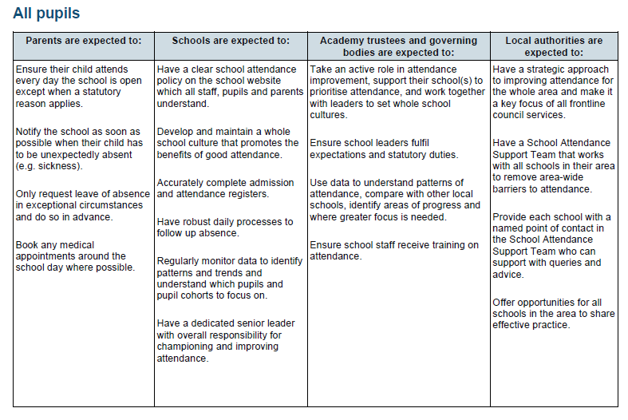

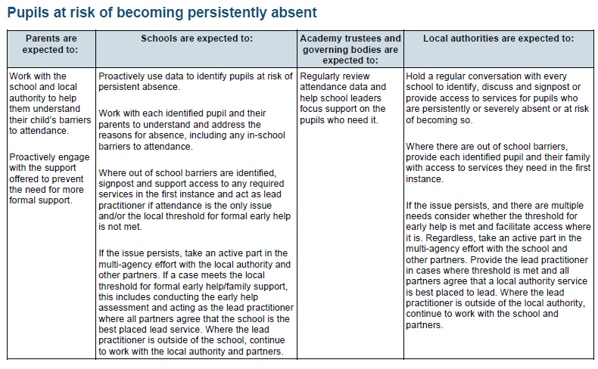
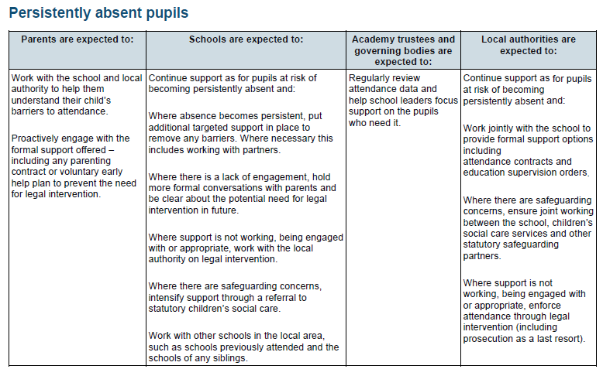

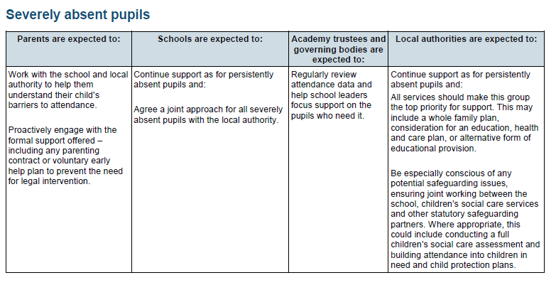

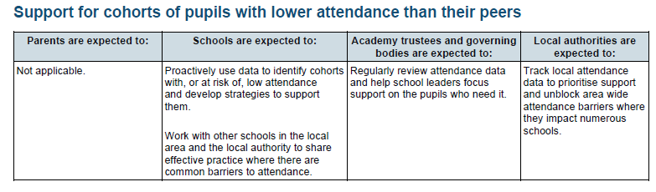
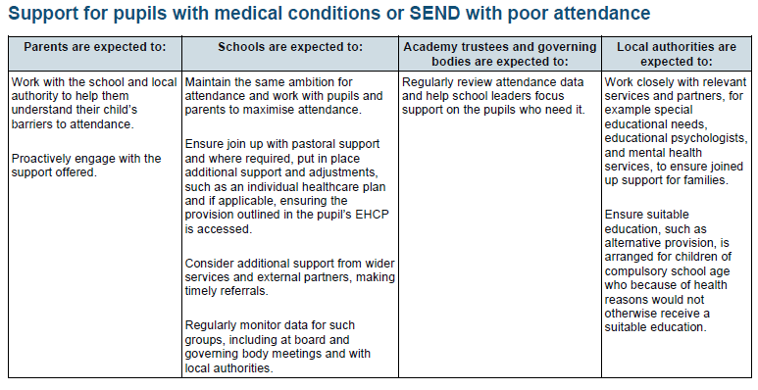
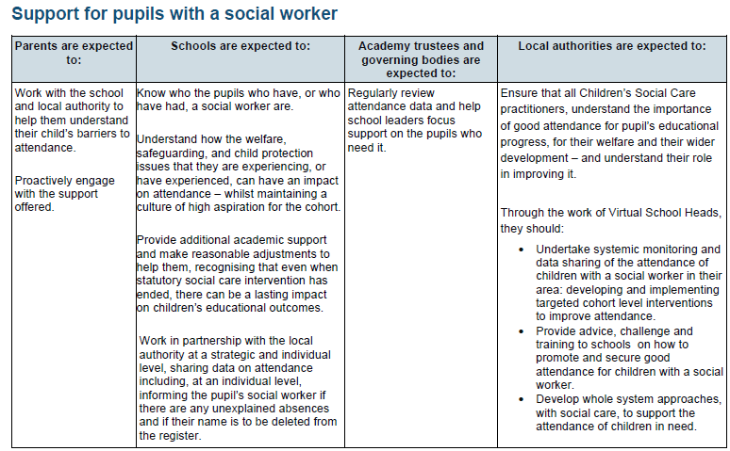

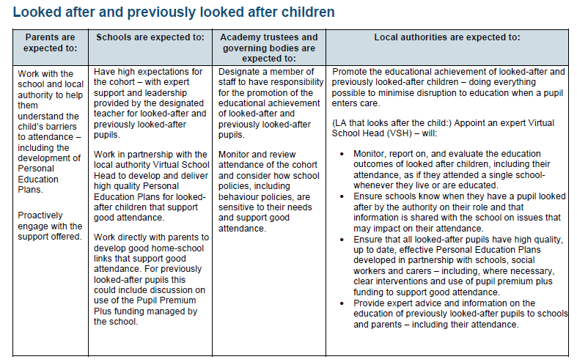

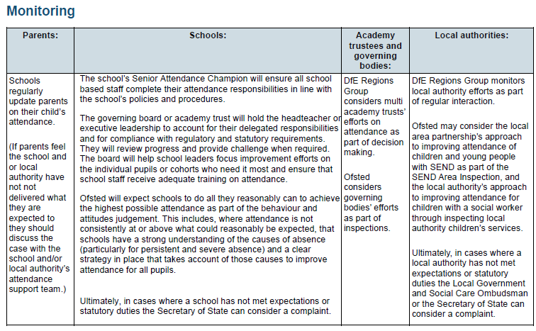

Appendix 2: NHS and Sandwell Council Guidance on School Absence and Childhood Illness.

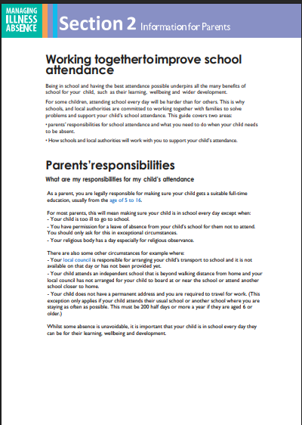
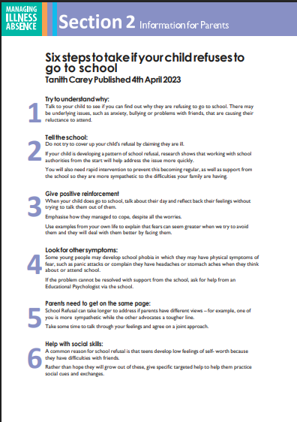
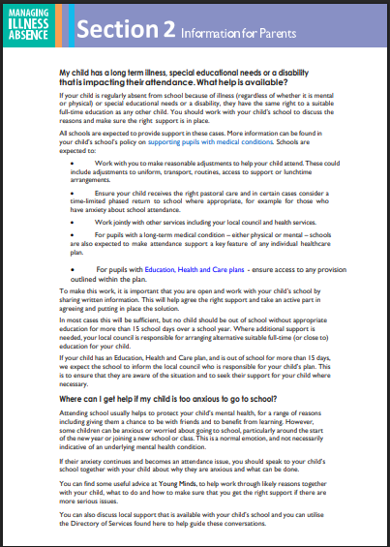
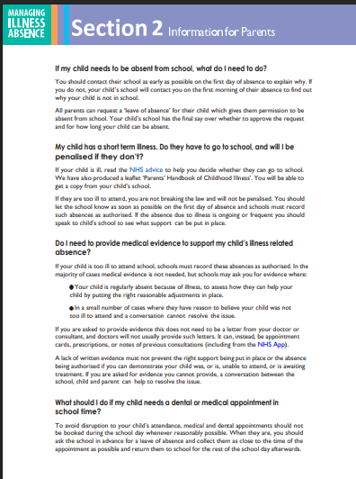

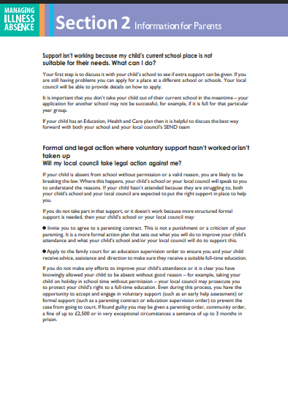

Appendix 3 – Graph of Impact

